OREGON SOILS DATA STANDARD
A COMPONENT OF THE OREGON GEOSCIENCE FRAMEWORK THEME

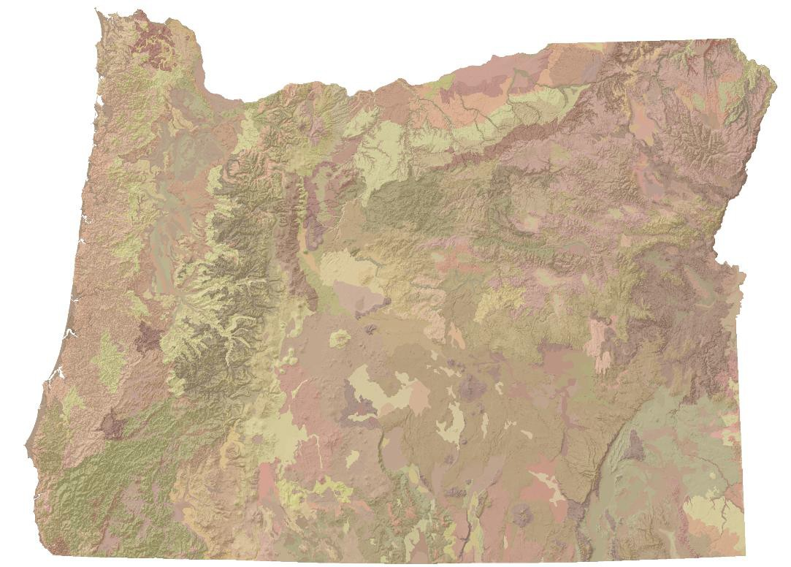

Prepared by:
Framework Soils Committee
Endorsed by Oregon Geographic Information Council, April 2022
For more information, contact:
Whityn Owen, USDA-NRCS
Oregon Geoscience FIT – Soils, Chair
1201 NE Lloyd Blvd. Ste. 900
Portland, OR 97232
whityn.owen@or.usda.gov

Contents
Abbreviations and Acronyms Used in this Document 4
1.0 INTRODUCTION 5
1.1 MISSION AND GOALS OF THE STANDARD 5
1.2 RELATIONSHIP TO EXISTING STANDARDS 6
1.3 DESCRIPTION OF THE STANDARD 7
1.4 APPLICABILITY AND INTENDED USE OF THE STANDARD 7
1.5 STANDARD DEVELOPMENT PROCEDURES 7
1.6 MAINTENANCE OF THE STANDARD 8
2.0 BODY OF THE STANDARD 8
2.1 SCOPE AND CONTENT OF THE STANDARD 8
2.2 NEED FOR THE STANDARD 9
2.3 PARTICIPATION IN STANDARDS DEVELOPMENT 9
2.4 INTEGRATION WITH OTHER STANDARDS 10
2.5 TECHNICAL AND OPERATIONAL CONTEXT 10
3.0 DATA CHARACTERISTICS 13
3.1 MINIMUM GRAPHIC DATA ELEMENTS 13
3.2 MINIMUM ATTRIBUTE OR NON‐GRAPHIC DATA ELEMENTS 13
3.3 OPTIONAL GRAPHIC DATA ELEMENTS 13
3.4 OPTIONAL ATTRIBUTE OR NON‐GRAPHIC DATA ELEMENTS 13
4.0 REFERENCES 14
Appendix A: SSURGO spatial metadata schema example, mupolygon table 15
15
Appendix B: SSSURGO metadata schema example, mapunit table. 16

Abbreviations and Acronyms Used in this Document

FGDC Federal Geospatial Data Committee
NCSS National Cooperative Soil Survey
NRCS Natural Resources Conservation Service
OGDS Oregon Geologic Data Standard
OSDS Oregon Soils Data Standard
OSFL Oregon Soils Framework Layer
SGDS Soil Geographic Data Standard
SSURGO Soil Survey Geographic Database
STATSGO State Soil Geographic dataset
STATSGO2 U.S. General Soil Map
USDA United States Department of Agriculture

1.0 INTRODUCTION
The Oregon Geographic Information Council (OGIC) is overseeing preparation of geospatial data standards for the state. The development of these standards will ease the sharing of data and assist cooperative data development efforts. OGIC assigned a Framework Implementation Team (FIT) to guide the development of standards for 15 statewide data themes. Separate (Oregon Framework) Work Groups are developing standards within each theme. Geoscience is one Oregon Framework theme with a Geologic workgroup guiding development of a Geologic Layer and a Soils workgroup coordinating a Soils Layer. This document concerns the Soils Layer.
This document is a standard for compiling soil map data statewide for Oregon. It is based on the National Cooperative Soil Survey (NCSS) standards and the Soil Geographic Data Standards of the Federal Geographic Data Committee (SGDS‐FGDC). These standards provide the structure for organizing, storing, and using a range of soils map data. The NCSS and SGDS‐FGDC data standards, as well as supporting methodologies, are designed for optimal use at 1:12,000 to 1:30,000 or smaller scales (FGDC, 1997) (Fig. 1). Most soil mapping in Oregon has been at a scale of 1:24,000, and certified data are distributed in the Soil Survey Geographic (SSURGO) Database standard.
As of this writing approximately 30% of the state either has not been mapped or is being mapped by an ongoing NCSS progressive soil survey. For these areas of the state where certified SSURGO datasets do not currently exist, U.S. General Soil Map (STATSGO2, formerly known as the State Soil Geographic (STATSGO) dataset) data will be used. STATSGO2 is a broad-based inventory of soils best represented at a map scale of 1:250,000 in Oregon.
This document outlines a content standard – the Oregon Soils Data Standard (OSDS) - emphasizing soil features, concepts, and relationships pertaining to information presented on soil maps. The standard addresses the graphic data elements held in a geographic information system (GIS) and the non‐ graphic descriptive information linked to the graphic elements, which could be organized in a relational database such as SSURGO.
This document does not provide guidance for site‐specific investigations of soils in Oregon that address needs for soils geospatial data at scales greater than 1:12,000 (e.g. 1:5,000). These high-intensity investigations are outside the scope of a typical NCSS SSURGO soil survey and no mechanism for cataloging or aggregating non-NCSS soils investigations is provided in this standard.

1.1 MISSION AND GOALS OF THE STANDARD
The mission of this standard is to provide a consistent and maintainable structure for soil map data being compiled statewide for Oregon. The name of this statewide compilation dataset is the Oregon Soils Framework Layer (OSFL). Its overall aim is to assist both producers and users of soil map data in Oregon. The following goals influenced development of this standard:
- To assemble the best available soils information statewide for Oregon.
    - To provide for periodic updates as new NCSS soils mapping is completed and provide a process and data structure to incorporate this new mapping into the OSFL.
    - Create a widely usable dataset and data structure, while acknowledging that soils terminology is extremely technical.

1.2 RELATIONSHIP TO EXISTING STANDARDS
The OSDS is directly related to the existing Soil Geographic Data Standards (SGDS) of the FGDC. The overall objective of the SGDS is to standardize the names, definitions, ranges of values, and other characteristics of soil survey map attribute data developed by the National Cooperative Soil Survey (NCSS) (FGDC, 1997). The NCSS is the body composed of the various federal, state, and local units of government who work cooperatively to develop the soil survey of all lands in the United States. The SGDS is a set of data standards for the inventory, mapping, and reporting on the soil resources of the United States. It includes a description of the proposed data elements to be used when reporting and transferring data used to describe soil map units and their components. These map units are associated with soil maps developed by the National Cooperative Soil Survey.
The OSDS data schema is identical to that of the SSURGO implementation of the SGDS standard. The OSFL spatial data are multi-resolution. The spatial data are dominantly SSURGO (1:24,000) but include STATSGO2 (1:250,000) data to infill areas where SSURGO is unavailable. The OSFL tabular data may have some missing data elements where those elements are not collected or where interpretations cannot be made at the smaller STATSGO2 mapping scale.
The SGDC does not detail data elements used to describe soils at a specific point/site on the landscape, the field methods used to collect the data, or the various classification systems used to classify soils.
Documents containing the field methods and various classification systems are listed as references at the end of this standard. The Oregon Geologic Data Model http://www.oregon.gov/geo/Pages/standards.aspx served as an important reference in designing the OSDS, as did the previous draft soil standard prepared by Dr. J. Noller, Department Head and Professor, Landscape Pedology, Department of Crop and Soil Science, Oregon State University.

1.3 DESCRIPTION OF THE STANDARD
This standard lays out the essential content and data structure necessary to describe, produce, and use the OSFL. These essential elements are a distillation of the important features normally included as the content of soil maps and deemed necessary for the statewide layer.
The standard addresses three organizational components:
- Geospatial elements (or geometry)
- Description of soils and soil map units
- Metadata for documentation
This standard has been written recognizing that: soils maps are complex and interpretive; the classifications of soils and soil‐landscape concepts interpretations have and will continue to evolve over time. Acknowledging these, the standard strives to be highly adaptive and refrains from re‐interpreting the data and interpretations the author developed in the original soils map.
An important part of the OSFL is the initial use of STATSGO2 data to produce a statewide soils layer because so much of the state remains unmapped or uncorrelated by NCSS standards. Over time, as soils mapping is completed in these areas SSURGO data will replace STATSGO and OSFL will approach full statewide soils coverage at a scale of 1:24,000.

1.4 APPLICABILITY AND INTENDED USE OF THE STANDARD
The intent of this standard is to foster the orderly development, sharing, and maintenance of the OSFL. This standard proposes using the consistent format, structure, and documentation of the SGDS-FGDC for the OSDS. It is a minimum standard intended to be usable by all levels of government, as well as academia and the private sector. As work on national soils data standards evolves this standard will evolve and strive to be compatible with such efforts.

1.5 STANDARD DEVELOPMENT PROCEDURES
The Oregon Geoscience Framework Group – Soils Committee, was formed in 2007 but an OSDS standard had not been approved by OGIC by early 2014. The current soils committee has met approximately quarterly since April 2014. The current committee reviewed the FGDC Soil Geographic Data Standards (SGDS) data model and heard a presentation of the standard and a proposal by the USDA Natural Resources Conservation Service (NRCS) to implement the SSURGO data model, filling in unmapped areas with STATSGO2 data. NRCS drafted a SSURGO/STATSGO2 soils layer which covers the entire state of Oregon. Elements of the draft model, map, and soils interpretive map examples were made available for wider review/comment on the Oregon Geospatial Enterprise Office (GEO) ftp site in 2015.

This site is hosted by the Oregon Department of Administrative Services.
Once approved the OSFL data will be made available through the GEO Spatial Data Library: http://www.oregon.gov/DAS/CIO/GEO/Pages/sdlibrary.aspx

1.6 MAINTENANCE OF THE STANDARD
The Soils Committee acknowledges that this standard will need periodic maintenance during preparation of the OSFL. Updates to this standard will be presented, when appropriate, to the Soils Committee for comment, revision, and final endorsement. The NRCS Oregon State Office will be the initial data steward for the OSFL and can remain so long as the OSDS standard is SGDS-FGDC compliant as implemented in SSURGO and STATSGO2. If the OSFL and OSDS evolve away from that then stewardship will have to shift to another entity, for example Oregon State University.

2.0 BODY OF THE STANDARD

2.1 SCOPE AND CONTENT OF THE STANDARD
The scope of this standard encompasses the public domain vector, raster, and associated tabular soils data compiled for the OSFL. Initially, the data set reflects current NCSS methodologies and SGDS-FGDC structure and will include SSURGO and STATSGO2 data. Map scales include a combination of 1:24,000 and 1:250,000. This standard adopts national standards that are applicable up to 1:12,000 scale. Over time the national standard may evolve by the modification or addition of geospatial and attribute elements. By adhering to that standard database structural changes can readily be applied to the OSFL.
When appropriate, such modifications and additions will be submitted to the Soils Committee for acceptance and the revised data content publicized to all interested users of the standard.
This standard does not include a standardized science language for describing, classifying and interpreting soils, including their description and classification. The standard soils language is encoded at the national level by NCSS.
No recommendation is made on how to archive, aggregate or incorporate site-specific data into the OFSL.

2.2 NEED FOR THE STANDARD
Soils maps are very diverse in the types of information that they contain and the soils‐related issues that they address. They are produced by State or Federal agencies, private industry consultants, and academic researchers according to well‐described, standard professional guidelines for content and form (see appendix). The features displayed on soils maps are interpretive and specific to each soils survey.

2.3 PARTICIPATION IN STANDARDS DEVELOPMENT
The Soils Committee is comprised of federal, state, and academic representatives. Participation in the Committee is open to all entities that are concerned with the production, use and exchange of statewide digital geologic information. Past and present member affiliations include:
    - Oregon Department of Administrative Services
    - Oregon Department of Agriculture
    - Oregon Department of Environmental Quality
    - Oregon Department of Geology & Mineral Industries
    - Oregon Department of Revenue
    - Oregon Department of Transportation
    - Oregon Watershed Enhancement Board
    - U.S. Bureau of Land Management
    - U.S. Forest Service
    - U.S. Geological Survey
    - U.S. Natural Resources Conservation Service
    - Oregon State University, Department of Crop and Soil Science, Soil Science Unit
This standard was tested and implemented in a pilot OSFL project in 2014. The project integrates SSURGO and STATSGO2 mapping in a layer covering the entire state of Oregon. Information regarding the pilot project is available from the NRCS Oregon State Office, State Soil Scientist, at 503-414-3200.

2.4 INTEGRATION WITH OTHER STANDARDS
The layout of this standard conforms to the OGIC layout template developed for the Oregon Framework Themes. Further, it is directly developed from the OGDS, with which it is partnered under the Oregon Geosciences Framework Theme. The documentation component of this standard is based on adoption of and full integration with the SGDS‐ FDGC standard.
The data environment for the OSFL is a vector model of polygons, lines, and points linked to relational database content. Additionally, a raster representation of soil polygons at 10-meter resolution is provided. Digital soils data elements are assembled in a variety of proprietary geospatial formats. The state exchange medium is the ESRI file geodatabase, a data structure relating polygons, lines, points and feature attribution (including shape geometry). To take full advantage of the OSFL, the user must properly link the file geodatabase feature classes or raster to the descriptive content in the tabular data.
The NRCS Web Soil Survey (WSS) website provides ready access to certified SSURGO and STATSGO2 data used in the OSFL. SSURGO is available by soil survey area, STATSGO2 data are available as a statewide download. In each case the spatial data are in shapefile format, the tabular data are in ascii text files.

2.5 TECHNICAL AND OPERATIONAL CONTEXT
Soils map information is commonly assembled and overlaid on a U.S. Geological Survey Digital Orthophoto quadrangle (DOQQ). DOQQs are typically provided in the Universal Transverse Mercator coordinate referencing system. However, for the OSFL, all soils information will be stored and exchanged in the custom Oregon Lambert Projection. This is the adopted standard projection among Oregon state agencies. Specific parameters of this projection can be found at http://www.oregon.gov/geo/Pages/projections.aspx
2.5.2 REFERENCE SYSTEMS
Soils are mapped based on climate, hydrology, biology (esp. vegetation), elevation, slope, landform, geology and other environmental factors. The integrative nature of soils mapping means that features (point, line, polygon) of the OSFL will locally to regionally show strong correspondence to Framework Layers carrying spatial information (e.g. vegetation map unit boundary) of these environmental factors.
2.5.3 INTEGRATION OF THEMES
Soils data incorporated into the OSFL will be encoded according to the SGDS-FGDC, adopted by the Soils Committee. Data dictionaries describing the specific format for the OSDS align with those currently published by the NCSS.
2.5.4 ENCODING

The resolution of the OSFL will vary according to the original reference soils map(s). The range of scales is initially 1:24,000 (SSURGO) and 1:250,000 (STATSGO2). As future NCSS SSURGO mapping is completed the proportion of 1:250,000 scale data will diminish.
2.5.5 RESOLUTION
This standard supports varying levels of positional accuracy, as implied by the range of original reference map scales. The accuracy of interpreted soils information varies with the scale of its base map. Soil map unit interpretations from the original written explanatory reference materials are carried directly into the relational database without reinterpretation, thereby promoting attribute accuracy.
2.5.6 ACCURACY
The concept of seamless geometry is not compatible with integration and maintenance of data from both SSURGO and STATSGO2 since these data sets use disparate map scales. However, since the two datasets share a common schema many thematic maps can be shown across the landscape.
2.5.7 EDGE MATCHING
Improvement in edge matching will occur as the OSFL continually incorporates new SSURGO mapping as progressive soil surveys are certified.
Each soil map unit polygon carries a non-connotative MUKEY attribute. This is the primary key that connects the polygon feature/instance to the tabular data.
2.5.8 FEATURE IDENTIFICATION CODE

2.5.9 ATTRIBUTES
2.5.9.1 POLYGONS
Polygons are geospatial objects that represent the boundaries of soils map units that have been mapped by a soil scientist and digitally encoded. Each polygon is uniquely identified according to the MUKEY attribute described in Section 2.5.8.

Lines are geospatial objects that represent the azimuths and locations of linear soils features mapped by a soil scientist and digitally encoded. Lines are uniquely identified according to the Feature Identification Code described in Section 2.5.8.
2.5.9.2 LINES
Points are geospatial objects that identify the location on the ground of soils‐ related feature sites. Points are uniquely identified according to the Feature Identification Code described in Section 2.5.8.
2.5.9.3 POINTS
The Oregon NRCS State Office serves as the data steward for the OSFL. NRCS will update the dataset on an annual basis or when new SSURGO certified data are available. Updates will include any newly certified SSURGO surveys and any modifications or additions to the attribute database.
2.5.10 TRANSACTIONAL UPDATING
Versions of the OSFL will be tracked by Oregon GIS Framework Coordinator, DAS/CIO Geospatial Enterprise Office. At a minimum, the OSFL versions will satisfy the archiving mandates applying to Oregon State agencies.
2.5.11 RECORDS MANAGEMENT
The OSDS uses the metadata standard for the SDGS-FGDC geospatial data. Metadata detailing the characteristics, content, and quality of soil map information is provided.
2.5.12 METADATA
Links to the SDGS-FGDC metadata standard are found in the References section of this document. SSURGO database schema examples appear in Appendices A and B.
Metadata recommendations for site-specific soil surveys are described in the proposed Oregon Site- Specific Soil Mapping Standards, Soils FIT, 2009.
Oregon NRCS will provide the spatial and tabular data in a single file geodatabase. The vector data will include soil map unit polygon and soil survey area boundary polygon feature classes. Additionally, a 10-meter raster representation of the soil polygon feature class will be included. Recognizing a rapidly evolving industry, this standard remains flexible to allow for the changes in data content, structure, and file formats necessary to remain current so long as the provisioned data meets the original intent. Specifically, at minimum the provisioned data will include a SSURGO-STATSGO blended product, a 10-meter raster representation of the soil polygon feature class, and all the SSURGO tabular information.
2.5.13 DATA PROVISIONING
NRCS will also provide ESRI ArcGIS Desktop layer (.lyr) files for the following interpretations:
- Suitability for Dwellings with no Basements (Dominant Condition)
- Farmland Class (Dominant Condition)
- Soil Hydrologic Group (Dominant Condition)
- Irrigated Land Capability Class (Dominant Condition)
- Non-Irrigated Capability Class (Dominant Condition)
NRCS is open to providing a limited number of additional Layer files if needed.

The data characteristics detailed below are subject to revision, based on continuing refinement of the OGDM. The data characteristics described in this section represent the minimum set of graphical and non‐graphical attributes required to meet this standard.

3.0 DATA CHARACTERISTICS

3.1 MINIMUM GRAPHIC DATA ELEMENTS
These are described in the SDGS-FGDC.

3.2 MINIMUM ATTRIBUTE OR NON‐GRAPHIC DATA ELEMENTS
These are described in the SDGS-FGDC.

3.3 OPTIONAL GRAPHIC DATA ELEMENTS
None specified at this time.

3.4 OPTIONAL ATTRIBUTE OR NON‐GRAPHIC DATA ELEMENTS
None specified at this time.

4.0 REFERENCES
Federal Geographic Data Committee (FGDC), 1997. Soil Geographic Data Standard. https://www.fgdc.gov/standards/projects/FGDC-standards-projects/soils/soil997.PDF (accessed 03/27/2019).
SSURGO/STATSGO2 Metadata and Documentation, (accessed 03/27/2019.) USDA-NRCS Soils Home Page, (accessed 03/27/2019.)
USDA-NRCS Web Soil Survey, create customized soil maps, print reports, view or download soil survey report text, create maps of soil properties and interpretations. Download soils data. (Accessed 03/27/2019.)

Appendix A: SSURGO spatial metadata schema example, mupolygon table
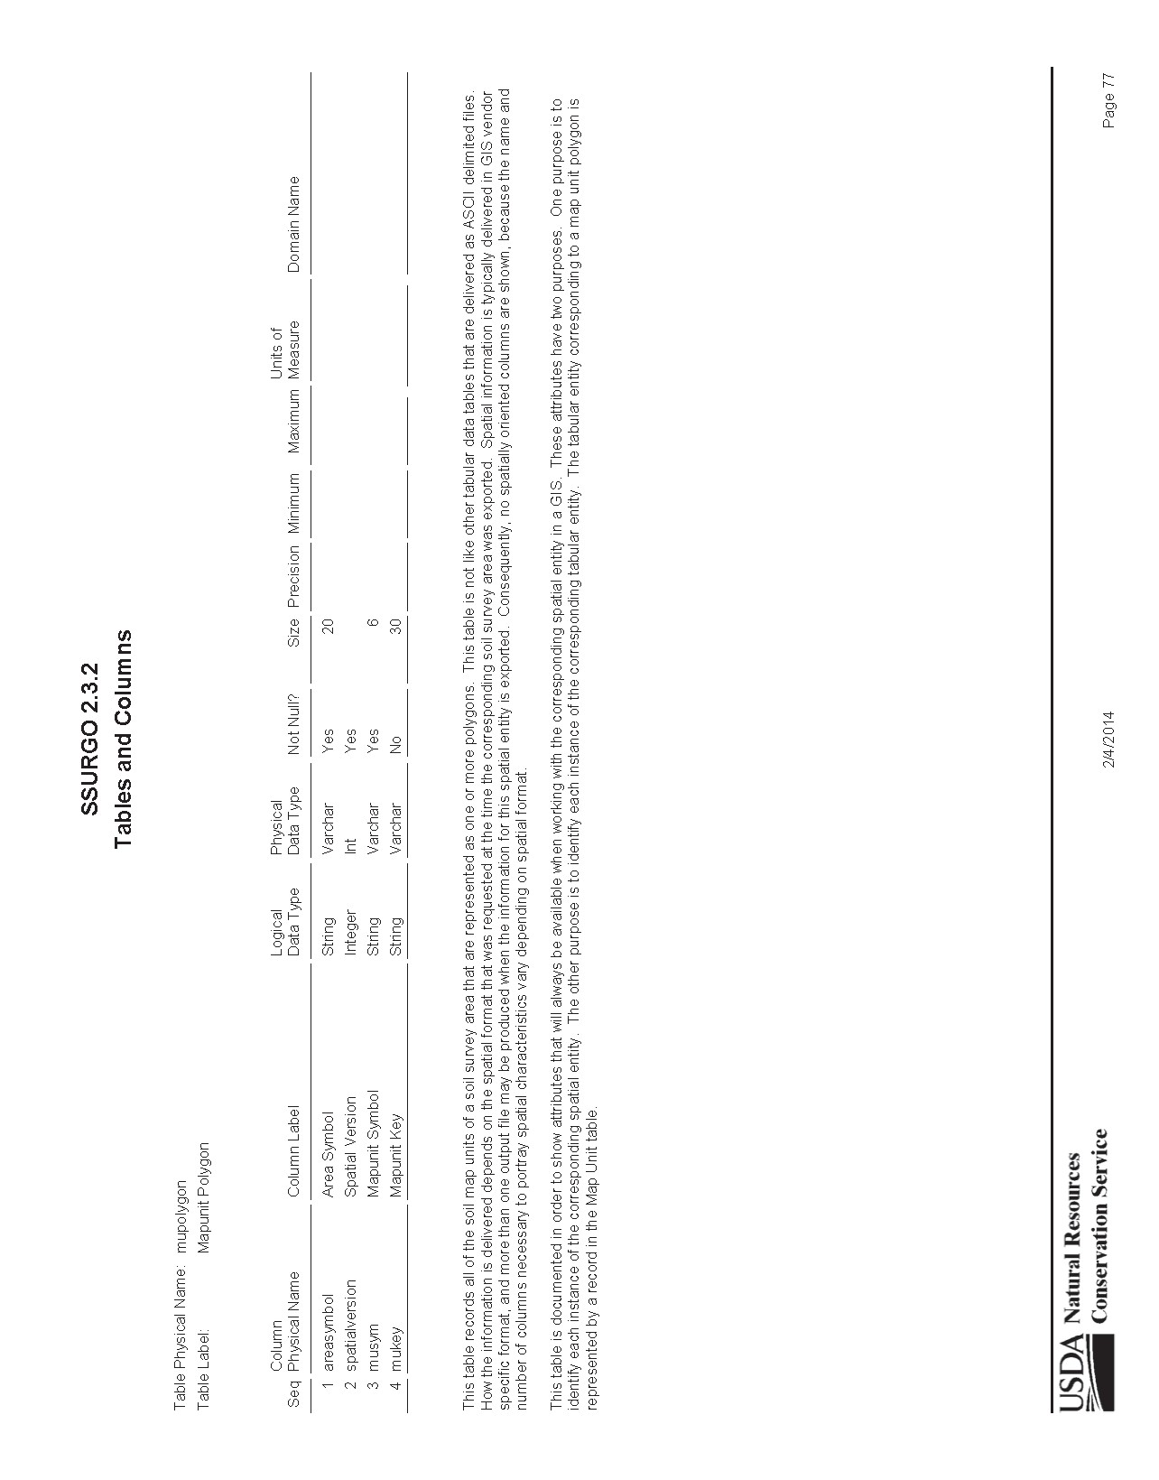

Appendix B: SSSURGO metadata schema example, mapunit table.
